Implementation of Active contour without edge
Su dongcai,2012-1-12; Email: suntree4152@gmail.com
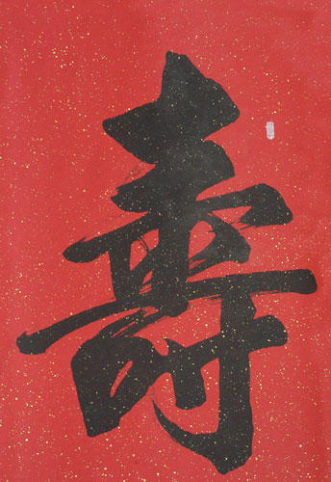
Fig1. original image.

Demonstration:
Now we try to draw the contour of the above Chinese character using active contour without edge algorithm[1] with the following command:
img = imread('shou.jpg'); img = rgb2gray(img);
demo_acwe(img, 100);
Note:
To avoid reinitialization, we applied the level set regularities term[2], see ‘acwe.m’ for details.
Fig2 & Fig3 show the result.
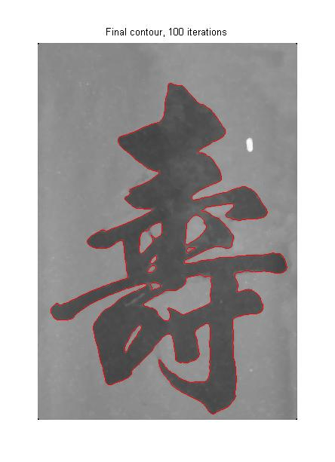
Fig2.0-level of the level set function phi

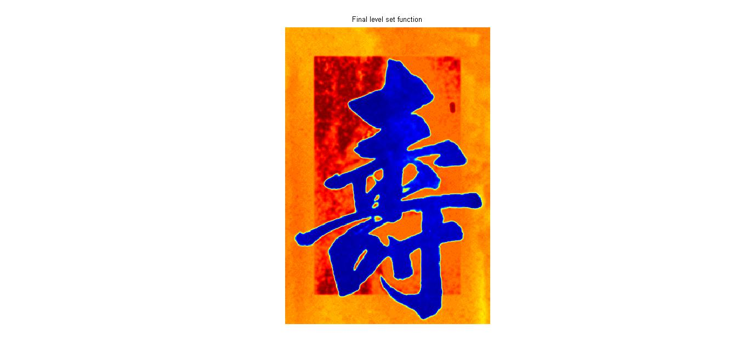
Fig3 color map(jet) of the output level set function phi.
Acknowledgement:
The author wish to thanks Li chunming for his clearly coded distribution:
http://www.mathworks.com/matlabcentral/fileexchange/12711-level-set-for-im
Reference:
[1]. Active contour without edge. chan etc
[2]. Minimizaion of region-scalable fitting energy for image segmentation.
IEEE Trans. Image Processing, vol. 17 (10), pp.1940-1949, 2008.by Li chunming etc.

